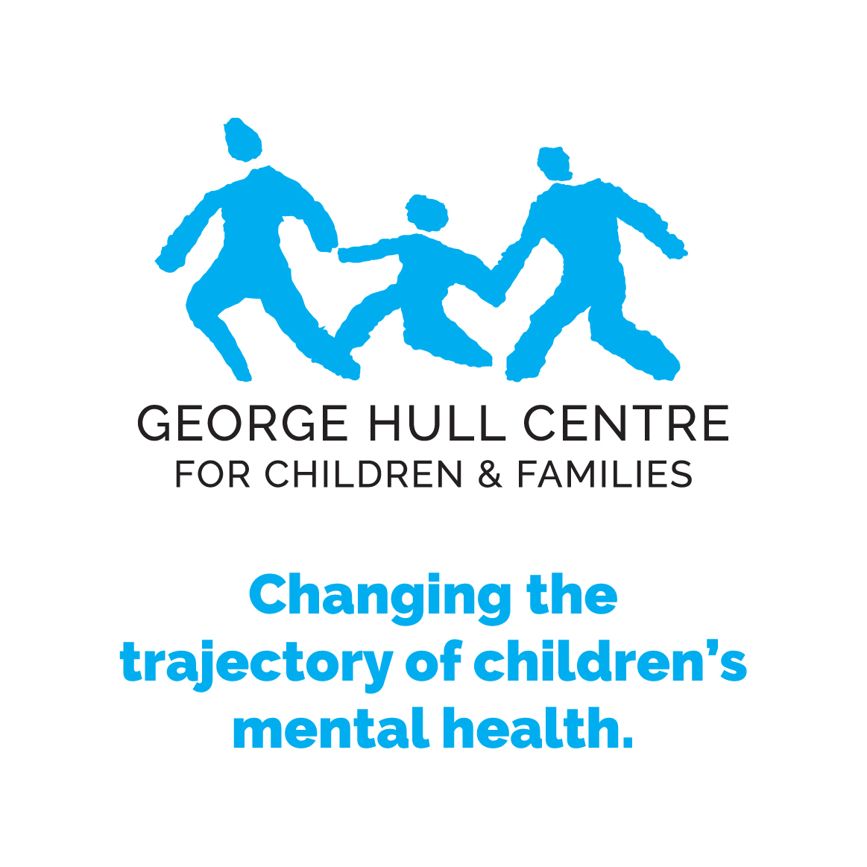 | GEORGE HULL CENTRE FOR CHILDREN AND FAMILIES  81 The East Mall, 3rd floor ♣ Toronto, ON M8Z 5W3  TEL 416-622-8833 ♣ FAX 416-622-7068
 | Dr Greg Lodenquai: Site Coordinator
Kellisa Webb, Administrative Assistant to Psychiatry
E-mail: kwebb@georgehull.on.ca
Ext: 294

The George Hull Centre for Children and Families offers psychiatric residents experiences in an outpatient community clinic, EarlyON prevention and early intervention program plus intensive in-home, day treatment and residential settings. The Community Clinic serves infants, school age children and adolescents and their families with a strong and cohesive multidisciplinary approach to assessment and treatment. The Clinic offers a range of evidence based treatments like CBT and DBT, as well as attachment based family and group treatments, such as Dyadic Developmental Psychotherapy and Circle of Security. Parental education groups, brief therapy and family therapy are also areas of expertise.

Settings and Clinical Services:
a) COMMUNITY CLINIC

The Community Clinic offers clinical services to families with children and youth from birth through 18 who are experiencing significant emotional, behavioural, developmental and/or psychiatric difficulties.

The Clinic Staff, comprised of psychiatry, psychology, social work and child and youth work, focus on family strengths and promoting positive outcomes for children and adolescents through comprehensive assessment, consultation and treatment.

Community Clinic offers the following:
An emphasis on sound, clinical and evidence-based practice
Education and advocacy for the prevention of mental health problems
Individual, family and group therapy
Partnerships with other organizations serving children and their families
Group treatments – CBT for anxiety, Fun Friends, Nurturing Attachments parent groups, DBT skills group for adolescents
Specialized expertise in Dyadic Developmental Psychotherapy and complex trauma

b) RESIDENTIAL, INTENSIVE IN-HOME AND DAY TREATMENT SERVICES

Residential treatment is provided to girls, ages 12-17, in Libby’s Place. Libby’s Place is a long term, adolescent residential treatment program. The clients have a variety of presenting difficulties ranging from mental health difficulties (OCD, Major Depression), attachment disruptions school refusal, family difficulties, child welfare involvement, substance use and academic difficulties.
Our Day Treatment Program, in partnership with the Toronto District School Board and the Toronto Catholic District School Board, provided therapeutic and academic programming to latency age children and adolescents. The partnership between the teacher and the child and youth workers is exemplary and essential and provides students with expert support for their academic and mental health needs.
The intensive in-home program comprehensive therapeutic services to adolescents and families with complex mental health needs in the context of their own homes by a team of child and youth workers, social workers and a consulting psychiatrist.

c) ONTARIO EarlyON CHILD AND FAMILY CENTRE

Over one thousand children, parents/caregivers participate in OEYC programs annually. Further there are eight to ten thousand child visits and parent/caregiver visits to the Ontario Early Years Centre.
Many participate in workshops on topics such as behaviour management, storytelling, baby signing, and a 5-week family math program. 121 professionals participate in workshops to prepare young children emotionally, socially, academically for the larger school age system.

Grand Rounds:

The George Hull Centre hosts educational rounds for its clinicians on a regular basis, which students are welcome to attend. Residents are encouraged to share their expertise through Grand Rounds presentations during their rotations at GHC, in what is a welcoming and relaxed atmosphere.

Psychotherapy:

Supervision is available at GHC for the following psychotherapy modalities: 1) family therapy; 2) Cognitive Behavioural Therapy (CBT); 3) adult psychodynamic psychotherapy; 5) Developmental Dyadic Psychotherapy (attachment-focused family therapy); 6) therapies for infants & preschoolers, including Watch, Wait & Wonder and Reflective Family Play

Supervision:
Staff Psychiatrists at the George Hull Centre for Children and Families are on Faculty at the University of Toronto and specialize in Child and Adolescent Psychiatry including early childhood developmental and attachment-related disorders, mood disorders, trauma and infancy and preschool development. Additional areas of expertise, by supervisor, are listed below:

Supervisors:

Dr. Greg Lodenquai - Staff Psychiatrist - 416-622-8833 ext. 227

Dr. Lodenquai is the Psychiatrist-in-Chief at the George Hull Centre. Dr Lodenquai's academic appointment is with the University of Toronto. He is also the psychiatric consultant to the George Hull intensive residential programs. Dr. Lodenquai has an interest in the area of psychopharmacology and CBT and is one of the consultants to the Telepsychiatry program through the Hospital for Sick Children. Dr Lodenquai provides primary supervision and supervision in CBT for residents at the Centre.

Dr. Taylor Armstrong - Staff Psychiatrist - 416-622-8833 ext. 232 – on leave September 2019-September 2020

Dr. Armstrong is the site coordinator for the George Hull Centre. His academic appointment is with the University of Toronto and provides primary supervision for residents training at the Centre. Clinically, Dr. Armstrong provides assessment and treatment for children and adolescents of a wide age range, and he has special interests in neuropsychiatry, adolescent mood disorders, attachment and developmental trauma, and the role of schools in improving the mental health of their students.

Dr. Upasana Krishnadev - Staff Psychiatrist – 416-622 8833 ext. 228

Dr.Krishnadev is the Psychotherapy Coordinator at the George Hull Centre, is the Co-Chair of the Child & Adolescent Psychiatry Curriculum Subcommittee. She is on faculty with the University of Toronto, and is actively involved in Postgraduate Education, particularly for the Child & Adolescent Psychiatry Subspecialty Program. Dr. Krishnadev provides both primary supervision for residents at the Centre and supervision in a variety of psychotherapy modalities, including family therapy; Watch, Wait & Wonder; Reflective Family Play (RFP), integrative psychotherapy and psychodynamic psychotherapy. Dr. Krishnadev provides community-based consultation to child care centres in the west end of the city. Her interests include working with families who have experienced developmental trauma, working with infants & preschoolers, and working with youth who experience emotion dysregulation. Dr. Krishnadev is also a consultant with the Telepsychiatry Program and Northern Psychiatric Outreach program, working with both Indigenous and Francophone populations in this content.

Reem Abdul Qadir, MSW, RSW – Educational Coordinator – 416-622 8833 ext. 245

Reem is the George Hull Centre’s Educational Coordinator. She coordinates the 11 week Family Therapy Training Program for MSW interns completing their practicums and paid externs. Reem supervises psychiatry residents in family therapy with a combination of readings, didactic discussion and live supervision.

